FS1 Distance Learning Plan - Week 2
20.9.20
 | Literacy | Maths
Sunday  20.09.20 | Today we will be listening to the story ‘While we can’t hug’ and identifying the different characters in the book (who).  Focus activity:  When you have listened to the story you can make your favourite character.  Print off the template of your favourite character (tortoise, hedgehog or owl) and decorate it using pens, pencils, paint or collage materials.  Can you send me a video on the class dojo portfolio of you holding up your favourite character and say ‘I like the.. (character name). | Today we are going to go on recap on the colours we have covered so far. We will be understanding the concept of matching colours.  Focused Activity:  Print out the worksheet and using a pencil match the animals to the correct colours.  Can you identify the colours using a simple sentence?
Monday  21.09.20 | Today we are going to use pens/pencils/paint/glue to make a picture/drawing for our friend (just like the hedgehog and tortoise did in the story).  Focus Activity:  You will be creating a picture for your friend.  Who is your friend?  What could you use to make the picture?  Please send me a video on the Class Dojo Portfolio of you talking about your picture. | Today we are going to be continue understanding the concept of identifying a range of colours and matching them.  Focused Activity:  Print out fish and cut out the circles. You will then be matching the circles onto the correct fish.  Which colours can you see?  Can you ask an adult to help you match the colours?
Tuesday  22.9.20 | Today we are going to think about how we could make each other feel happy like the Hedgehog and the Tortoise did in the story.  Focus Activity:  Can you listen to the story and print the pictures to help you to think about what you could do in the scenario to make someone feel better?  Let’s remember what the Hedgehog and Tortoise did to make each other feel happy even though they couldn’t hug (waved, smiled, made funny faces, wrote a letter, danced, blew a kiss, sang, painted a picture)  Can you send me a video on the class dojo portfolio and tell me what you would do to make your friend happy? | Today we will be going to be sorting these pictures into the same coloured border.  Focused Activity:  Take a look at these pictures:  What colour can you see?  Can you ask an adult to help you cut around the pictures?  Can you sort the pictures into the corresponding coloured border?
Wednesday  23.9.20 | Today we are going to think about our favourite part of the story “While We Can’t Hug”.  We will look at some pictures from the story/book to help us decide.  Focus Activity:  Can you look at the pictures of the hedgehog and tortoise trying to make each other happy that you printed yesterday (or you can print them again if you do not have them) and think about which picture part of the story is your favourite?  Can you send me a video on the class dojo portfolio of you talking about (showing me the picture) of your favourite part of the story “The tortoise is singing”? | We are going to be identifying all the colours we have learnt over the last few weeks. We then will create a paper plate animal as a class.  Focused Activity:  You will then create your very own paper plate animal.
Thursday  24.9.20 | We have enjoyed listening to the story `While We Can’t Hug’ and learned about how the characters (Hedgehog and Tortoise) made each other happy.  Today we will arrange some pictures of the hedgehog in the correct order of what happened first, next and last in the story.  Focus Activity:  Can you print the pictures of the Tortoise and Hedgehog for today’s activity and put them in order?  What happens first, next and last?  Please send me a photo of how you have ordered the pictures on the Class Dojo Portfolio. | Today, we are going to go on a colour hunt. We will look for all the colours we have found.  Focused Activity:  Can you collect all of your favourite items and identify each colour?  Challenge: Count the items you have in total in a loud, clear voice to your mummy/daddy.
Phonics | Listening Ears: What sounds can you hear outside? What is your favourite sound?
ICT | https://pbskids.org/sid/games/sorting-box Sorting coloured rocks
Personal, Social, Emotional Development | 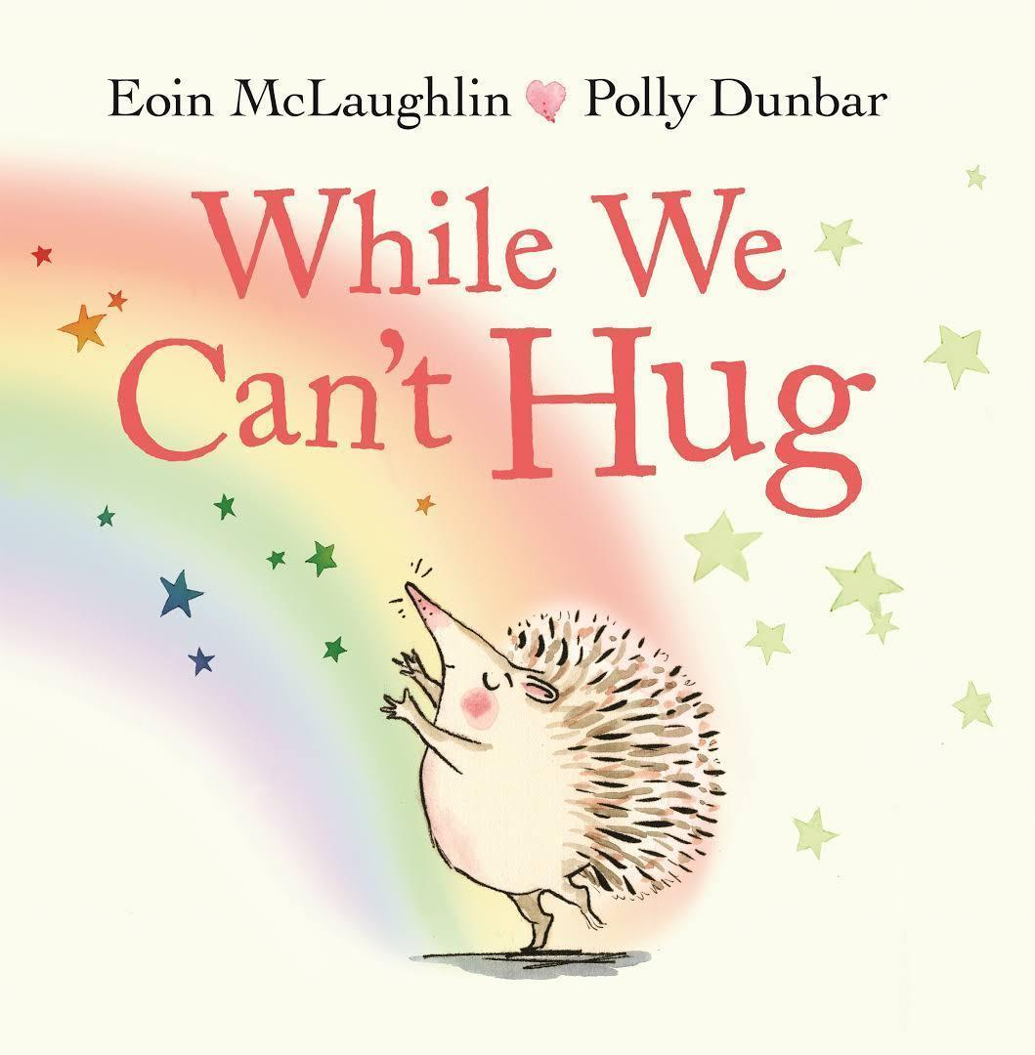  This week we will continue to listen to the story ‘While we can’t Hug” and think about how we can make each other feel happy.
Story Time | You can find our daily story time on the FS1 Weebly Website by following this link:

