Week 1 Distance Learning
12.9.20
 | Literacy | Maths
Sunday  30.8.20 | Today we are going to be listening to the ‘while we can’t hug’. We will be learning to name Identify) things and characters in the story (hedgehog, tortoise, owl, letter, paint, paint brush, rain, sunshine and rainbow).  Focused Activity:  Listen to the ‘While We Can’t Hug’ story. What did you see in the story? Can you identify the things in the story by name? Can you say what you can see? MTYT ‘I see a hedgehog’ etc. Please print the activity sheet with pictures from the story and identify what you can see. Send me a video on the class dojo portfolio of you identifying the things from the story by name. | Today we are going to be sorting and matching objects around our home according to their colour.  The colour we will be learning is red.  Focus activity:  Can you print the coloured sorting circles?  Can you find the red circle? Can you say, “This is red”?  Look for objects around your home that are the same colour. When you have found them can you put them on the red circle and then send me a video on the dojo portfolio of you saying “This is red”?
Monday  1.9.20 | Today we will be listening to the ‘While We Can’t Hug’ story. We will be learning to identify action words such as waving, smiling, writing and painting.  Focused Activity:  Listen to the ‘while we can’t hug’ story. What did the Hedgehog and Tortoise do? Please print the flashcards of the different actions and identify the waving, smiling, laughing, writing, dancing/moving, singing and painting actions. Can you say what you see? MTYT ‘this is smiling’ etc. Send me a video of you identifying different actions from the story. | We will continue to match/sort and identify objects according to their colour. Today we will be focusing on the colour yellow.  Focus activity:  Can you print the Yellow matching/sorting sheet? Can you find the objects that are yellow? Can you say “This is yellow”? Can you draw a circle around (make a line through) the objects that are yellow. Can you send the completed activity sheet on the class dojo portfolio and say “this is yellow” using a full sentence when you find something yellow at home?
Tuesday | Today we will be listening to the ‘While We Can’t Hug’ story. We will be continuing to identify action words from the story. We will be selecting an action, doing the action and saying what the action is, “I am waving”.  Focused Activity: Listen to the story ‘While We Can’t Hug’ and identify when you see the Hedgehog or Tortoise waving, smiling, laughing, writing, dancing/moving, singing and painting. Please use the action cards from yesterday’s activity and select your favourite action. Send me a video of you carrying out the action and saying what you are doing, “I am smiling”. | We will continue to match/sort and identify objects according to their colour. Today we will be focusing on the colour blue.  Focus activity:  Please can you print the Blue matching/sorting sheet? Can you identify (find/point to) the blue objects? Can you say ‘this is blue’?  Can you stick the blue objects on the blue sorting sheet?  Please can you send me a picture of your completed work on the class dojo portfolio?
Wednesday  3.9.20 | Today we will be listening to the new story and thinking about which character in the story is our favourite. Can you remember the characters we see in the story “While we can’t Hug”(The Hedgehog, Tortoise and Owl)?.  Focus Activity:  Can you print the sheet with the characters from the story and circle your favourite (hedgehog/tortoise/owl)? Can you point to the characters and say their names? “I can see a ….” Can you send me a video on the class dojo telling me who your favourite character is and why? “I like the …. because….”” | Today we will be focusing on the colour green and identifying green items in the kitchen/ refrigerator.  Focus Activity:  Can you identify any of the vegetables on the sheet? What are they called? Can you identify the colour of the vegetables (What colour are they)? Do you have any of these vegetables in your kitchen/refrigerator? Can you send me a video of you showing me what you have found and what colour it is? “Broccoli is green”, a “green apple”..
Thursday  4.9.20 | Do you remember that the tortoise and hedgehog both painted a rainbow to make each other happy? Today we will be listening to the rainbow song and thinking about our favourite colour. Can you sing along to the rainbow song?  Can you name your favourite colour?  Focus Activity:  Can you print the Rainbow song poster? Can you point to the colours of the rainbow as you sing? Can you colour the rainbow poster in and send me a video on the Class Dojo portfolio and tell me what your favourite colour is? “I like the colour ….” | Today we will be matching/sorting and identifying objects around our home that are red, yellow, blue and green.  Focus Activity:  We will be going on a colour hunt, searching for green, red, blue and yellow objects around your house. Can you please print the shape hunt tick sheet. When you find a coloured object can you draw a line or make a mark next to the colour on the sheet. Remember to say ‘This is a red....’. When you have found objects that represent each of the 4 colours we have been learning can you sort them into the same colours (all the red together). Please send me a video on the class dojo portfolio of you identifying the different colours you have sorted.
Phonics | To have Listening Ears. What sounds can you hear at home?
ICT | https://pbskids.org/sid/games/sorting-box Sorting coloured rocks  https://www.youtube.com/watch?v=2PnnFrPaRgY watch the story  Education city, paint pals (choosing the colours).
Personal, Social, Emotional Development | 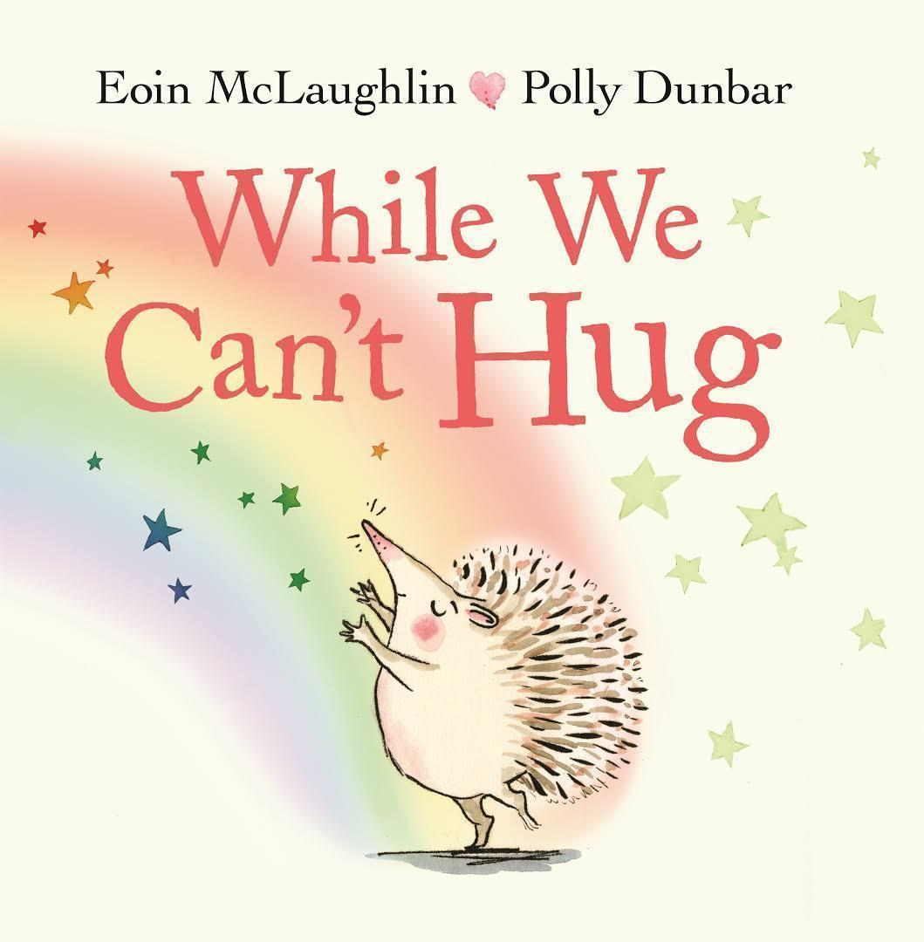  This week we will be reading the story ‘While we can’t hug’. We will talk about how we can show our feeling to friends in fun ways, while still staying safe!
Story Time  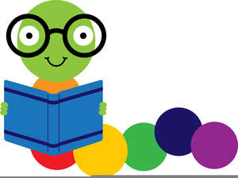 | You can find our daily story time on the FS1 Weebly Website by following this link:

